Chapter 4
The Organization of Life
Section 1
Day 1
Defining an Ecosystem
- __________________________________ are communities of organisms and their abiotic environment.
- Examples are an ___________________________________________________.
- Ecosystems do not have clear boundaries.
- Things move from one ecosystem to another.
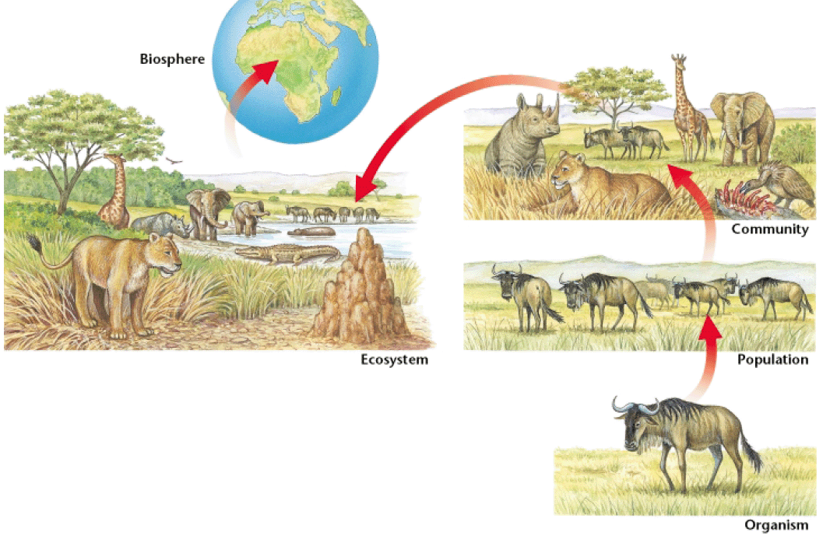
- Pollen can blow from a forest into a field, soil can wash from a mountain into a lake, and birds migrate from state to state.

The Components of an Ecosystem
- In order to survive, ecosystems need five basic components:
  - _________________________________
  - _________________________________
  - _________________________________
  - _________________________________
  - _________________________________
- Plants and rocks are components of the land ecosystems, while most of the energy of an ecosystem comes from the ___________________________.
- If one part of the ecosystem is destroyed or changes, the entire system will be affected.
Biotic and Abiotic Factors
- ____________________________________________ are environmental factors that are associated with or results from the ______________________________________________________, which includes plants, animals, dead organisms, and the waste products of organisms.
- _______________________________________________ are environmental factors that are _______________________________________________ with the activities of living organisms which includes air, water, rocks, and temperature.
- Scientists can organize these living and nonliving things into various levels.
Organisms
- _____________________________________ are living things that can carry out life processes independently.
- You are an organism, as is an ant, and ivy plant, and each of the many bacteria living in your intestines.
- Every organism is a member of a species.
- _____________________________________ are groups of organisms that are closely related can mate to produce fertile offspring.
Populations
- Members of a species may not all live in the same place.
- Field mice in Maine will not interact with field mice in Texas. However, each organism lives as part of a population.
- _____________________________________ are groups of organisms of the same species that live in a specific geographical area and interbreed.
- For example, all the field mice in a cornfield make up a population of field mice.

Populations
- An important characteristic of a population is that its members _________________________________________________________________ rather than with members of other populations
- For example, bison will usually mate with another member of the same herd, just as other flowers in the same field will usually pollinate wildflowers.
Communities
- __________________________________________ are groups of various species that live in the same habitat and interact with each other.
- __________________________________________ is part of a community.
- The most obvious difference between communities is the __________________________________________ they have.
- Land communities are often dominated by a few species of plants. These plants then determine what other organisms can live in that community.
Habitat
- ______________________________________ are places where an organism usually lives.
- Every habitat has specific characteristics that the organisms that live there need to survive. If any of these factors change, the habitat changes.
- Organisms tend to be very _________________________________ to their natural habitats.
- In fact, animals and plants usually cannot survive for long periods away from their natural habitat.

Chapter 4
Organization of Life
Section 2
Day 1

Evolution by Natural Selection
- English naturalist _______________________________________ observed that organisms in a population differ slightly from each other in form, function, and behavior.
- Some of these differences are _____________________________________.
- Darwin proposed that the _________________________________________ a strong influence over which individuals survive to produce offspring, and that some individuals, because of certain traits, are more likely to survive and reproduce than other individuals are.
Evolution by Natural Selection
- _____________________________________ is the process by which individuals that have favorable variations and are better adapted to their environment survive and reproduce more successfully than less well adapted individuals do.
- Darwin proposed that over many generations, natural selection causes the characteristics of ____________________________________________.
- _________________________________________ is a change in the characteristics of a population from one generation to the next.
Nature Selects
- Darwin thought that nature selects for certain traits, such as sharper claws, because organisms with these traits are __________________________________________________________________.
- Over time, the population includes a greater and greater proportion of organisms with the ________________________________________.
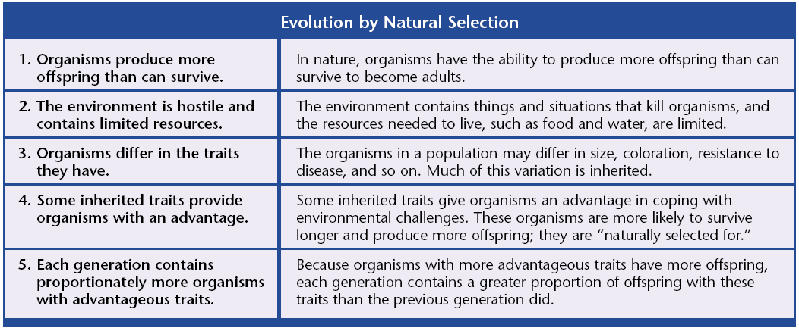
- As the populations of a given species change, so does the species.
Nature Selects
- An example of evolution is a population of deer that became isolated in a cold area.
- Some of the deer had genes for thicker, warmer fur.
- These deer were more likely to survive, and their young with thick fur were more likely to survive to reproduce.
- _______________________ is the process of becoming adapted to an environment.
- It is an _______________________________________________________________________.
Coevolution
- The process of two species evolving in response to long-term interactions with each other is called _________________________________.
- An example is the ___________________________________________, which has a long, curved beak to reach nectar at the base of a flower.
- The flower has structures that ensure that the bird gets some pollen on its head.
- When the bird moves the next flower, some of the pollen will be transferred, helping it to reproduce.
Coevolution
- The honeycreeper’s adaptation is a ______________________________________.
- The plant has two adaptations:
  - The first is the ____________________________, which attracts the birds.
  - The second is the ______________________________ that forces pollen onto the bird’s head when the bird sips nectar.
Evolution by Artificial Selection
- _______________________________________________ is the selective breeding of organisms, by humans, for specific desirable characteristics.
- Dogs have been bred for certain characteristics.
- Fruits, grains, and vegetables are also produced by artificial selection.
- Humans save seeds from the largest and sweetest fruits.
- By selecting for these traits, farmers direct the evolution of crop plants to produce larger, sweeter fruit.
Evolution of Resistance
- _______________________________________ is the ability of an organism to tolerate a chemical or disease-causing agent.
- An organism may be resistant to a chemical _______________________________________________________________________.
- Humans promote the evolution of resistant populations by trying to _______________________________________________________________________.
Pesticide Resistance
- A pesticide sprayed on corn to kill grasshoppers, for example, may kill most of the grasshoppers, but those that survive happen to have a gene that protects them from the pesticide.
- These surviving insects pass on this resistant gene to their offspring.
- Each time the corn is sprayed; more grasshoppers that are resistant enter the population.
- Eventually the entire population will be resistant, making the pesticide useless.

Chapter 4
Organization of Life
Section 3
Day 1
The Diversity of Living Things
- Most scientists classify organisms into __________________ kingdoms based on different characteristics.
- Members of the six kingdoms get their food in different ways and are made up of different types of ____________________, the smallest unit of biological organization.
- The cells of animals, plants, fungi, and protists all contain a ______________________.
- While cells of bacteria, fungi, and plants all have _______________________________.
Kingdom | Characteristics | Examples
Archaebacteria |  | Methanogens (live in swamps and produce methane gas) and extreme thermophiles (live in hot springs)
Eubacteria |  | Proteobacteria (common in soils and in animal intestines) and cyanobacteria (also called blue-green algae)
Fungi |  | Yeasts, mushrooms, molds, mildews, and rusts
Protists |  | Diatoms, dinoflagellates (red tide), amoebas, trypanosomes, paramecia, and Euglena.
Plants |  | Ferns, mosses, trees, herbs, and grasses
Animals |  | Corals, sponges, worms, insects, fish, reptiles, birds, and mammals

Bacteria
- ______________________________________ are extremely small, single-celled organisms that usually have a cell wall and reproduce by cell division.
- Unlike all other organisms, bacteria lack _______________________________.
- There are two main kinds of bacteria, ________________________________________________________________.
- Most bacteria are eubacteria.
- Bacteria live in every habitat on Earth, from hot springs to the bodies of animals.
Bacteria and the Environment
- Some kinds of bacteria _________________________________________________________________ of other organisms and return the nutrients to the soil.
- Others recycle nutrients, such as _______________________________________________.
- Certain bacteria can convert nitrogen from the air into a form that plants can use.
- This conversion is important because nitrogen is the main component of ________________________________________________.
Bacteria and the Environment
- Bacteria also allow many organisms, including humans, to extract certain nutrients from their food.
- The bacterium, Escherichia coli or ___________________________, is found in the intestines of humans and other animals and helps digest food and release vitamins that humans need.
Fungi
- A _________________________________ is an organism whose cells have nuclei, rigid cell walls, and no chlorophyll and that belongs to the kingdom Fungi.
- ___________________________________ act like mini-skeletons that allow fungi to stand up right.
- A _________________________________ is the reproductive structure of a fungus.
- The rest of the fungus is an underground network of fibers that absorb food from decaying organisms in the soil.
Fungi
- Fungi get their food by ____________________________________ that help break down organic matter, and then absorbing the nutrients.
- The bodies of most fungi are huge networks of threads that grow through the soil dead wood, or other material on which the fungi is feeding.
- Like bacteria, fungi play an important role in ___________________________________________________________________.
Fungi
- Some fungi, like some bacteria, cause ____________________________________.
- _______________________________________ is an example of a condition caused by fungi.
- Other fungi add flavor to food as in blue cheese. The fungus gives the cheese both its blue color and strong flavor.
- Yeasts are fungi that produce the gas that makes bread rise.
Protists
- _________________________are diverse organisms that belong to the kingdom Protista.
- Some, like amoebas, are animal like. Others are plantlike, such as kelp, and some resemble fungi.
- Most protists are ________________________________________________, including diatoms, which float on the ocean surface,
- Another protist, __________________________________, is the one-celled organism that causes the disease malaria.
Protists
- From an environmental standpoint, the most important protists are ______________________.
- Algae are plantlike protists that can make their ___________________________________________________________________.
- They range in size from the giant kelp to the one-celled phytoplankton, which are the initial source of food in most ocean and freshwater ecosystems.
Plants
- Plants are many-celled organisms that make their own food ___________________________________________________________________.
- Most plants live on land where they use their leaves to get sunlight, oxygen, and carbon dioxide from the air.
- Plants absorb nutrients and water from the soil using their roots.
- __________________________________ are connected by vascular tissue, which has thick cell walls and serves is system of tubes that carries water and food.
Lower Plants
- The first land plants had no vascular tissue, and swimming sperm.
- They therefore had to live in damp places and could not grow very large.
- Their descendents alive today are small plants such as __________________________.
- ________________________________________were the first vascular plants, with some of the ferns being as large as small trees.
Gymnosperms
- _______________________________________ are woody vascular see plants whose seeds are not enclosed by an ovary or fruit.
- __________________________________________________ are gymnosperms that bear cones.
- Much or our lumber and paper comes from gymnosperms.
Gymnosperms
- Gymnosperms have several adaptations that allow them to live in drier conditions than lower plants.
  - They can produce _______________________, which protects and moves sperm between plants.
  - These plants also produce ____________________, which protect developing plants from drying out.
  - A conifer’s _________________________________ also lose little water.
Angiosperms
- ______________________________________are flowering plants that produce seeds within fruit. Most land plants are angiosperms.
- The ___________________________________ is the reproductive structure of the plant.
- Some angiosperms, like grasses, have small flowers that use wind to disperse their pollen.
- Other angiosperms have large flowers to attract insects and birds.
- Many flowering plants depend on animals to disperse their seeds and carry their pollen.
Angiosperms
- Most land animals are dependent on _________________________________________.
- Most of the food we eat, such as wheat, rice, beans, oranges, and lettuce comes from flowering plants.
- Building materials and fibers, such as oak and cotton also come from flowering plants.
Animals
- Animals cannot make their own food. They must take it in from the environment.
- Animal cells also have no cell walls, making their bodies soft and flexible.
- Some animals have evolved hard exoskeletons.
- As a result, animals are much more mobile than plants.
- All animals move around in their environment during at least one stage in their lives.
Invertebrates
- ______________________________________ are animals that do not have backbones.
- Many invertebrates live attached to hard surfaces in the ocean and filter their food out of the water, such as corals, various worms, and mollusks.
- These organisms are only mobile when they are _________________________.
- At this early stage in their life, they are part of the ocean’s plankton.
Invertebrates
- Other invertebrates, including squid in the ocean and insects on land, actively move in search of food.
- More ______________________________ exist on Earth than any other type of animal.
- Insects are successful for many reasons:
  - _____________________________________________________
  - _____________________________________________________
  - _____________________________________________________
  - their __________________________________________ allows them to live on little food and to hide from enemies in small places.
Invertebrates
- Many insects and plants have evolved together and depend on each other to survive.
- Insects carry pollen from male fruit parts to fertilize a plant’s egg, which develops into fruits such as tomatoes, cucumbers, and apples.
- Insects are also valuable because they eat other insects that we consider pests.
Invertebrates
- However, insects and humans are often enemies.
- Bloodsucking insects transmit human diseases such as _______________________________________________________________________.
- Insects do most damage indirectly by eating our crops.
Vertebrates
- ________________________________________ are animals that have a backbone, and includes mammals, birds, reptiles, amphibians, and fish.
- The first vertebrates were _________________________, but today most vertebrates live on land.
- The first land vertebrates were __________________________.
- These animals were successful because they have an almost ______________________________________________, which allows the egg to hatch on land, away from predators in the water.
Vertebrates
- Birds are _________________________________ vertebrates with feathers.
- They keep their hard-shelled eggs and young warm until they have developed insulating layers of fat and feathers.
- Mammals are warm-blooded vertebrates that have __________________________________________________________________.
- Birds and mammals have the ability to maintain a high body temperature, which allows them to live in cold areas, where other animals cannot live.

