The Human Population

- What environmental resistance factors were faced by humans during the hunter-gatherer period?

- What about human society changed during the agricultural revolution?

  - What effect did this have on the population?

- What density-dependent limiting factors still affected the human population following the agricultural revolution?

- List five new technologies that emerged following the industrial revolution.

- Define infant mortality –

  - What happened to infant mortality during the industrial revolution?

  - How did infant mortality affect life expectancy?

- Define exponential growth –

- Define doubling time –

  - Give the equation for calculating doubling time.

- Define demographics –

- Developing countries tend to be:

  - Older or Younger?

  - Poor or wealthy?

  - Growing in population size or shrinking?

- Developed countries tend to be:

  - Older or Younger?

  - Poor or wealthy?

  - Growing in population size or shrinking?

- Label the developed and developing regions on this population growth graph.

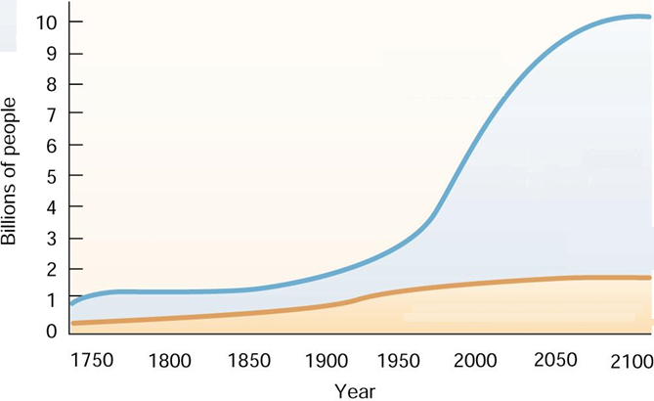

- Define each of these important demographic variables:

  - Life Expectancy –

  - Total Fertility Rate –

  - Gross Domestic Product per capita –

- Fill in the demographic data for these two countries:

Country | GDP Per Capita | Total Fertility Rate | Life Expectancy
United States
Afghanistan

- What is the correlation between life expectancy and GDP?

- Define emigration –

- Define immigration –

- Define pronatalist pressure –

- Define antinatalist pressure –

- List examples of each type of pressure.

Pronatalist Pressures | Antinatalist Pressures

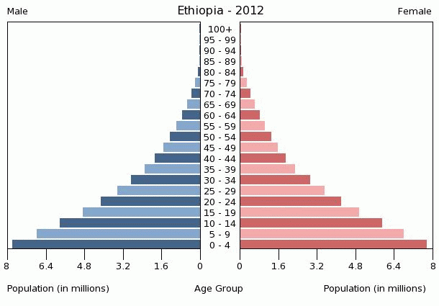
Demographic Transition Model

- Describe the birth rate, death rate, and living conditions for countries in the pre-industrial stage.

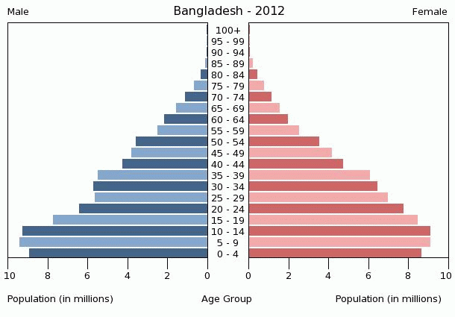

- What changes occur as countries enter the early transition stage?

- What changes occur as countries enter the late transition stage?
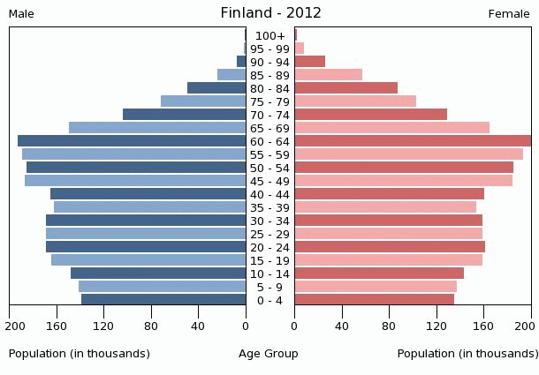

- What changes occur as countries enter the industrial stage?

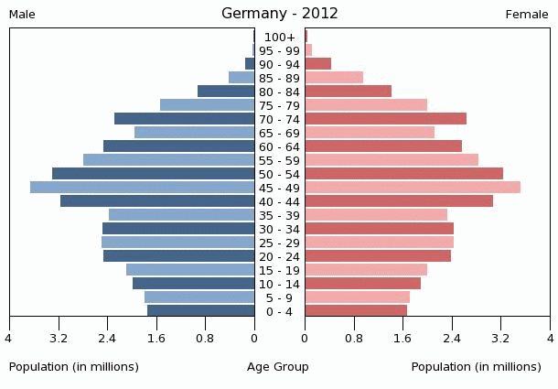

- What happens to populations of countries in the post-industrial stage?

- Label the preindustrial, transitional, industrial, and post-industrial stages on this graph.
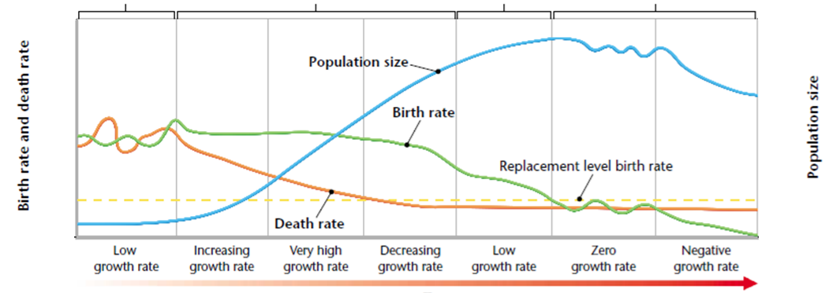

- Give the maximum population size projections:

  - Low: ____________

  - Medium: ___________

  - High: ____________

