Chapter 1
Science and the Environment
Section 1: Understanding Our Environment
Day 1
What Is Environmental Science?
- ____________________________________________________ is the study of the air, water, and land surrounding an organism or a community, which ranges from a small area to Earth’s entire biosphere.
- It includes the study of the impact of _______________________________________________________________________.
What is the Goal of Environmental Science?
- A major goal of environmental science is to _______________________________________________________________________.
- To accomplish this goal, environmental scientists study two main types of interactions between humans and their environment:
  - ________________________________________________________________.
  - 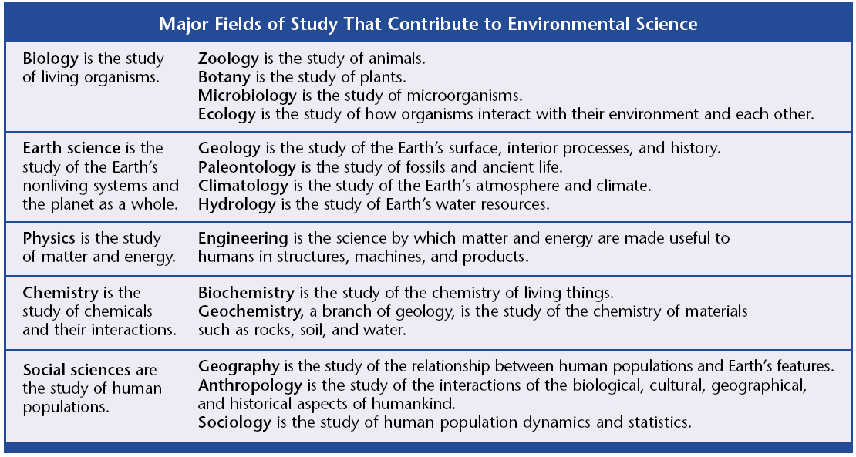________________________________________________________________
Many Fields of Study
- Environmental science is an interdisciplinary science, which means that it involves many fields of study.
- Important to the foundation of environmental science is ecology.
- ________________________________ is they study of interactions of living organisms with one another and with their environment.
- ________________________________ is the study of living things.
- ________________________________ is the study of chemicals and their interactions.
- ________________________________ is the study of matter and energy.
Scientists as Citizens, Citizens as Scientists
- Governments, businesses, and cities recognize that studying our environment is vital to maintaining a healthy and productive society.
- Thus, environmental scientists are often asked to share their research with the world.
- However, the __________________________________________________________ are the first steps toward addressing an environmental problem.
Our Environment through Time
- Wherever humans have hunted, grown food, or settled, they have changed the environment.
- For example, the environmental change that occurred on Manhattan Island over the last 300 years was immense, yet that period was just a “blink” in human history.
First Impact: Hunter-Gatherers
- ________________________________________________ are people who obtain food by collecting plants and by hunting wild animals or scavenging their remains.
- Hunter-gatherers affect their environment in many ways:
  - Native American tribes ______________________________________________.
  - The tribes also set _________________________________________________________________. This left the prairie as an open grassland ideal for hunting bison.
First Impact: Hunter-Gatherers
- In North America, a combination of rapid climate changes and overhunting by hunter-gatherers may have led to the disappearance of some large mammal species, including:
  - __________________________________
  - __________________________________
  - __________________________________
  - __________________________________
  - __________________________________
The Agricultural Revolution
- _________________________________________ is the raising of crops and livestock for food or for other products that are useful to humans.
- The practice of agriculture started in many different parts of the world over _______________________________________ ago.
- The change had such a dramatic impact on human societies and their environment that it is often called the ________________________________________________________.
The Agricultural Revolution
- The Agricultural Revolution allowed human populations to grow at an unprecedented rate.
- As populations grew, they began to ______________________________________________________________________ on the local environments.
The Agricultural Revolution
- The agricultural revolution changed the food we eat.
- The plants we grow and eat today are descended from ________________________________.
- However, during harvest season farmers collected seeds from plants that exhibited the qualities they desired, such as ________________________________________.
- These seeds were then planted and harvested again. Overtime, the domesticated plants became very different from their wild ancestors.
The Agricultural Revolution
- Many habitats were destroyed as grasslands, forests, and wetlands were replaced with farmland.
- Replacing forest with farmland on a large scale can cause _____________________________________________________________________.
The Agricultural Revolution
- The ________________________________________________ technique was one of the earliest ways that land was converted to farmland.
- Much of this converted land was poorly farmed and is no longer fertile.
The Industrial Revolution
- The Industrial Revolution involved a shift from energy sources such as ______________________________________________________________________.
- This increased use of fossil fuels changed society and greatly increased the efficiency of ______________________________________________________________________.
- For example, motorized vehicles allowed food to be transported cheaply across greater distances.
The Industrial Revolution
- In factories, the large-scale production of goods became less expensive than the local production of handmade goods.
- On the farm, machinery reduced the amount of land and human labor needed to produce food.
- With fewer people producing their own food, the populations in urban areas steadily grew.

Graphic Organizer: Our Environment Through Time

- Please put the graphic organizer below. It will be part of your notebook check.
- The instructions for the graphic organizer are located on page 9 of your textbook.
- Comparison table instructions are located in the appendix (back of the book) on page 616.

