Study Guide for Unit 2: Cells & Histology
Cell Structure
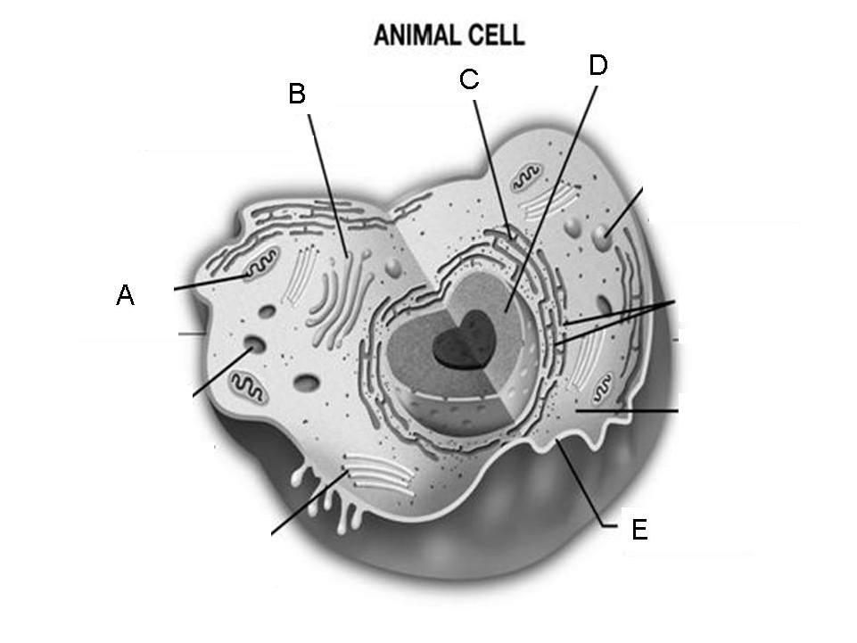
- Complete the following chart: 2. Identify the labeled organelles:
A) _______________________
Organelle | Function
Nucleus
Ribosome
Smooth Endoplasmic reticulum
Rough Endoplasmic reticulum
Golgi apparatus
Mitochondria
B) _______________________
C) _______________________
D) _______________________
E) _______________________

Cell Membrane and Movement Across the Membrane
3. Describe the structure of the cell membrane Recognize the structures in the diagram. |  | 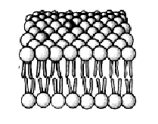
4. Describe equilibrium. Do molecules still move? Explain why or why not.
5. What is diffusion? Why does diffusion occur? | What?
5. What is diffusion? Why does diffusion occur? | Why?
6. What is osmosis?

7. Define semipermeable.

8. What is Passive Transport?  List and describe the 3 types. | Define:
 | 1)
 | 2)
 | 3)
9. What is Active Transport?  List and describe the 3 types. | Define:
9. What is Active Transport?  List and describe the 3 types. | 1)
9. What is Active Transport?  List and describe the 3 types. | 2)
9. What is Active Transport?  List and describe the 3 types. | 3)

Histology
10. What is histology?

11. What is a tissue?

12. What are the 4 types of tissues and the functions? | Tissue Type | Function
12. What are the 4 types of tissues and the functions? | 1.
12. What are the 4 types of tissues and the functions? | 2.
12. What are the 4 types of tissues and the functions? | 3.
12. What are the 4 types of tissues and the functions? | 4.
Epithelial Tissues
13. Describe simple epithelial tissue.
14. Describe stratified epithelial tissue.
15. Describe columnar epithelial tissue.
16. What is the function of the cilia found in the epithelium cell?
17. What structure attaches cells to underlying tissues.?

Connective Tissues
18. What are the 4 main types of connective tissues? | 1. |  | 3.
18. What are the 4 main types of connective tissues? | 2. |  | 4.
19. What are the functions of connective tissue?
20. What is the matrix and why is it important?
21. Where is loose connective tissue found and what is its function?
22. What type of tissue is adipose tissue?
12. What are the 3 types of cartilage? | 1.  2.  3.
23. What type of cartilage is found on the nose and outer ear? | Nose-  Outer Ear-
24. What are the 2 types of bone tissue? | 1.  2.
25. Where are blood cells made?
26. Where are chondrocyte cells found?
27. What are two types of fibrous connective tissue? Describe where each is found. | 1.
 | 2.

Muscle & Nervous Tissue
28. What are the 3 types of muscular tissue? Describe each | 1.
28. What are the 3 types of muscular tissue? Describe each | 2.
28. What are the 3 types of muscular tissue? Describe each | 3.
29. What is the overall function of muscular tissue?
30. Which type of muscle is voluntary?
31. Which types (2) of muscle is involuntary?
32. Where are cardiac muscles found?
33. What are neurons?

34. Where is nervous tissue found?
35. Label the structures on the neuron:  Dendrites, axon, cell body, nucleus, axon terminals, node | 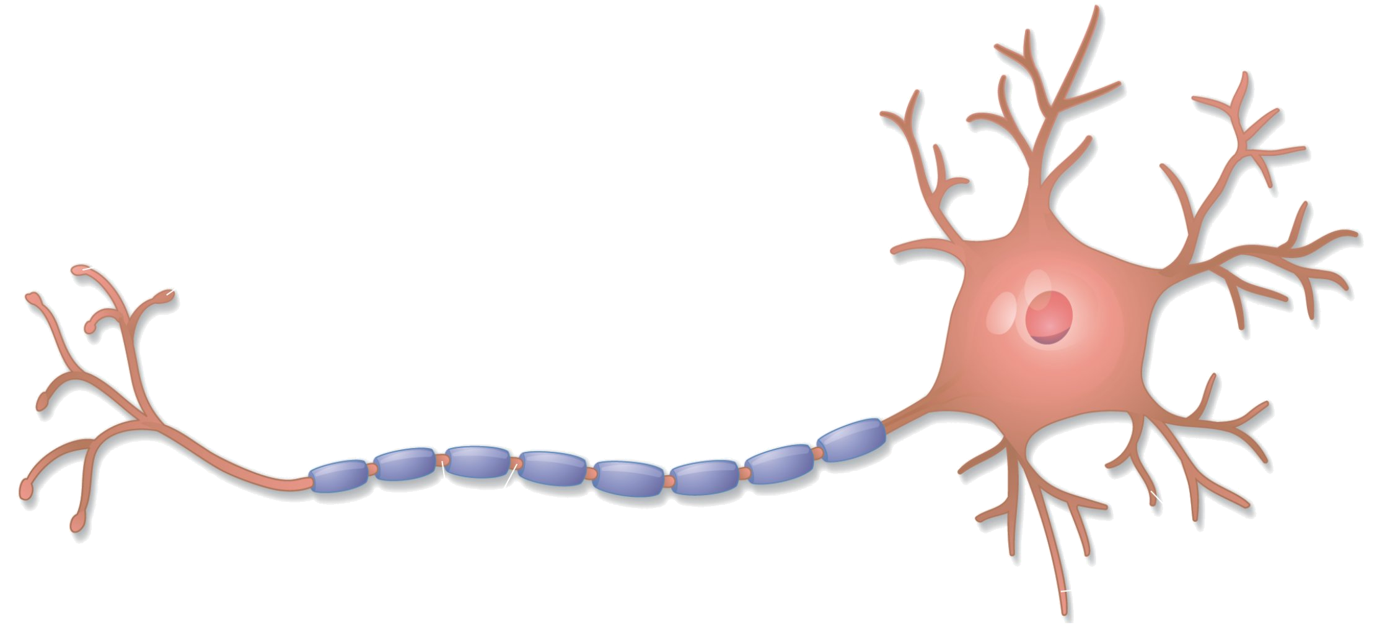

36. For each of the following diagrams, identify the category (epithelial, connective, muscular, or nervous) of the tissue and then the specific name of the tissue.
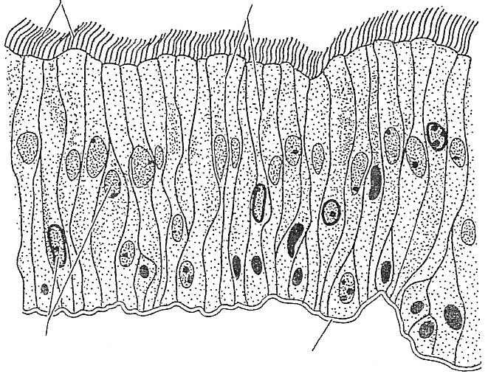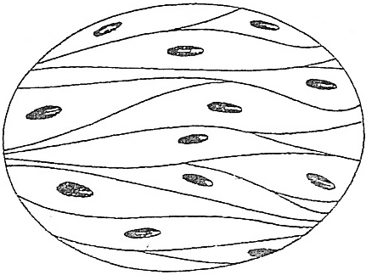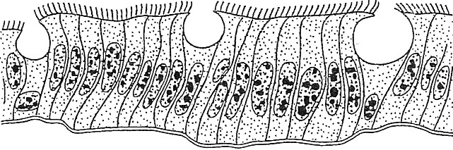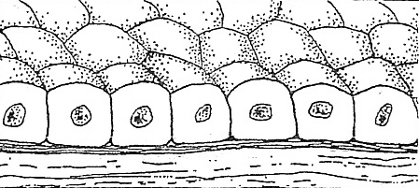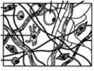
Category ______________________ ___________________ _______________________ ________________________ ____________________
Type ______________________ ___________________ _______________________ ________________________ ____________________

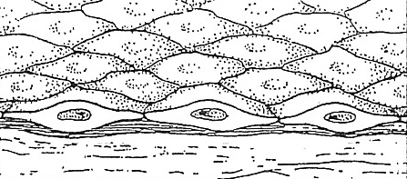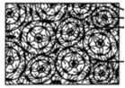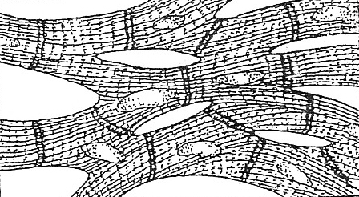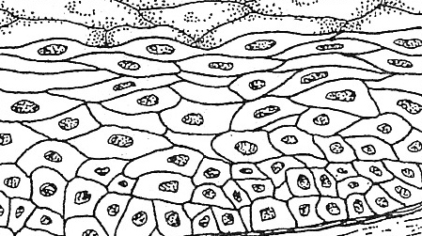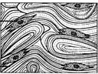
Category ______________________ ___________________ _______________________ ________________________ ____________________
Type ______________________ ___________________ _______________________ ________________________ ____________________

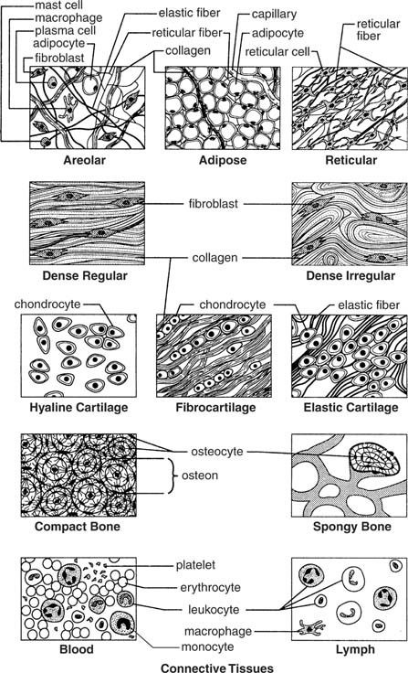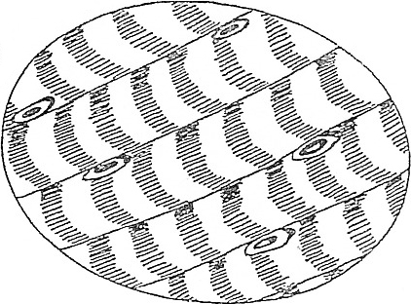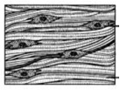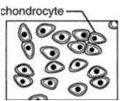
Category ______________________ ___________________ _______________________ ________________________ ____________________
Type ______________________ ___________________ _______________________ ________________________ ____________________

